Apache官方上传组件示例

第一步：将以下jar文件拷贝到/WEB-INF/lib目录中
- commons-fileupload-1.2.jar
- commons-io-1.4.jar

第二步：创建upload.html
/upload.html源码
<html>
<head>
<title>upload.html</title>
<meta http-equiv="content-type" content="text/html;charset=utf-8">
</head>
<body>
<form action="UploadServlet" method="post" enctype="multipart/form-data">
请选择上传的文件
<input type="file" name="f1">
<input type="submit" value="立即上传">
</form>
</body>
</html>

截屏效果
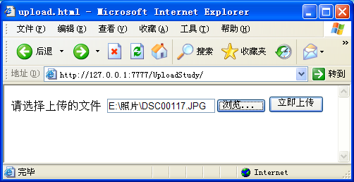

注意：<form>标签中的enctype属性值一定要设置为multipart/form-data

第三步：创建UploadServlet类
UploadServlet.java源码
package com.servlet;

import java.io.*;
import javax.servlet.*;
import javax.servlet.http.*;
import java.util.*;
import org.apache.commons.fileupload.*;
import org.apache.commons.fileupload.disk.*;
import org.apache.commons.fileupload.servlet.*;

public class UploadServlet extends HttpServlet {
public void doPost(HttpServletRequest request, HttpServletResponse response)
throws IOException, ServletException {
// 设置编码
request.setCharacterEncoding("utf-8");
response.setContentType("text/html;charset=utf-8");
PrintWriter out = response.getWriter();

// 获得Servlet上下文对象
ServletContext context = this.getServletContext();

// 磁盘文件列表工厂对象
DiskFileItemFactory fact = new DiskFileItemFactory();

// Servlet文件上传对象
ServletFileUpload upload = new ServletFileUpload(fact);

// 获得上传列表
try {
// 设置最大上传文件大小为1M，超出大小会发生异常
upload.setSizeMax(1024 * 1024 * 1);

// 获得所有上传文件对象集合
List<FileItem> list = upload.parseRequest(request);

// 获得第一个文件对象
FileItem item = list.get(0);

// 文件大小
long fileSize = item.getSize();

// 客户端文件路径
String fullName = item.getName();
// 原始文件名称
String oldFileName = fullName
.substring(fullName.lastIndexOf("\\") + 1);
// 扩展名
String extName = oldFileName
.substring(oldFileName.lastIndexOf("."));
// 生成新文件名称(当前毫秒数连接1~1000随机数)
String newFileName = System.currentTimeMillis() + ""
+ (int)((1000 - 1 + 1) * Math.random() + 1) + extName;

// 设置上传文件夹和临时文件夹的物理路径
String uploadPath = context.getRealPath("/myupload");

// 创建文件对象
File file = new File(uploadPath + File.separator + newFileName);
// 写入文件（上传文件）
item.write(file);

// 输出上传文件信息
out.println("原始文件名:" + oldFileName);
out.println("<br>");
out.println("现在文件名:" + newFileName);
out.println("<br>");
out.println("文件大小：" + fileSize);
out.println("<br>");
out.println("存放位置：" + uploadPath);
out.println("<br>");

} catch (FileUploadException e) {
e.printStackTrace();
} catch (Exception e) {
e.printStackTrace();
}
}
}

配置web.xml文件
<servlet>
<servlet-name>UploadServlet</servlet-name>
<servlet-class>com.servlet.UploadServlet</servlet-class>
</servlet>
<servlet-mapping>
<servlet-name>UploadServlet</servlet-name>
<url-pattern>/UploadServlet</url-pattern>
</servlet-mapping>

运行最终结果
